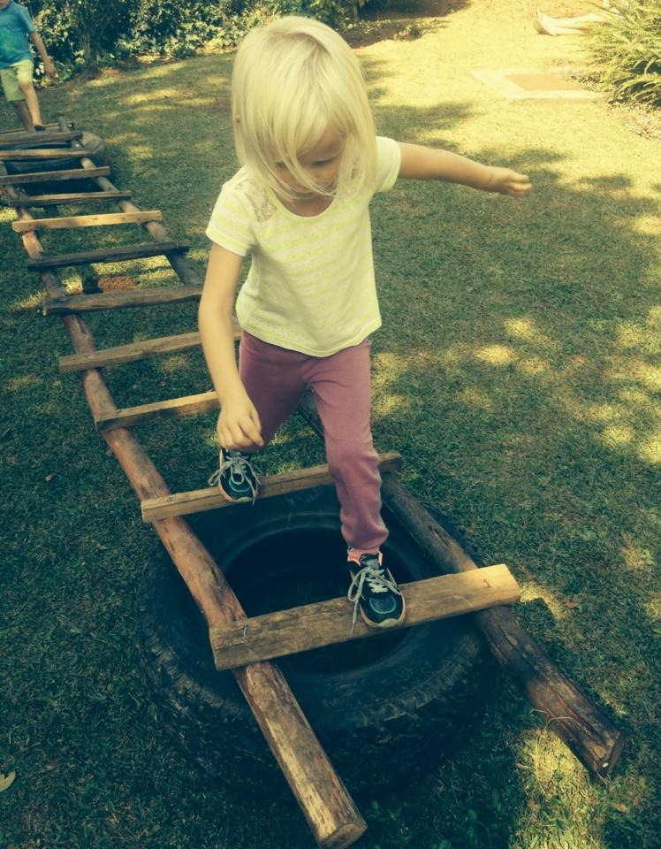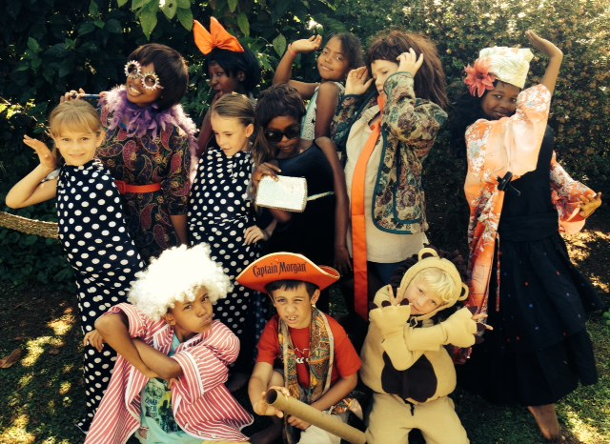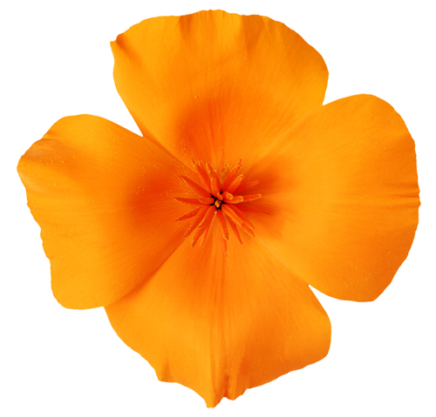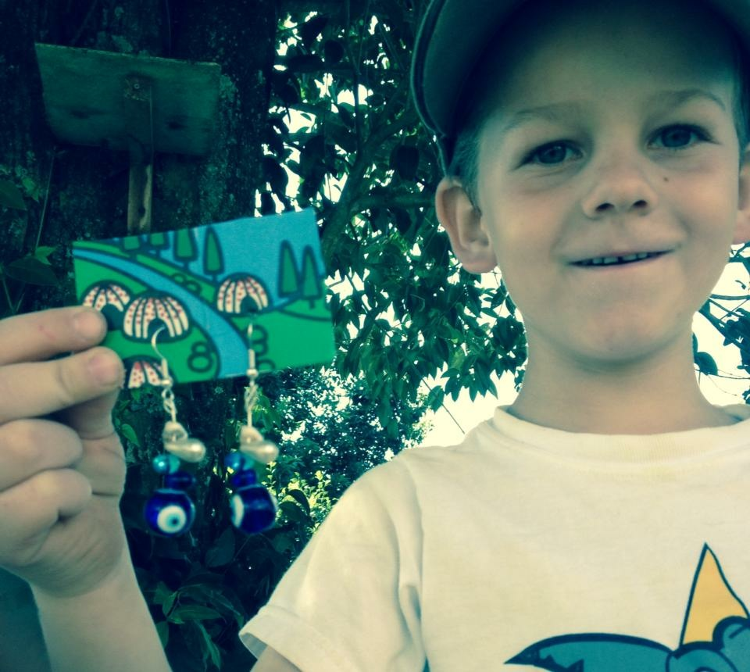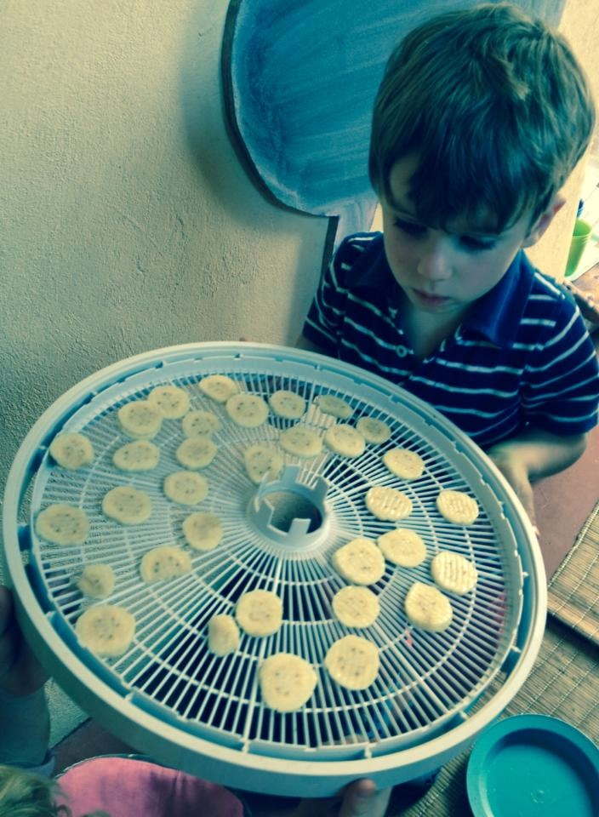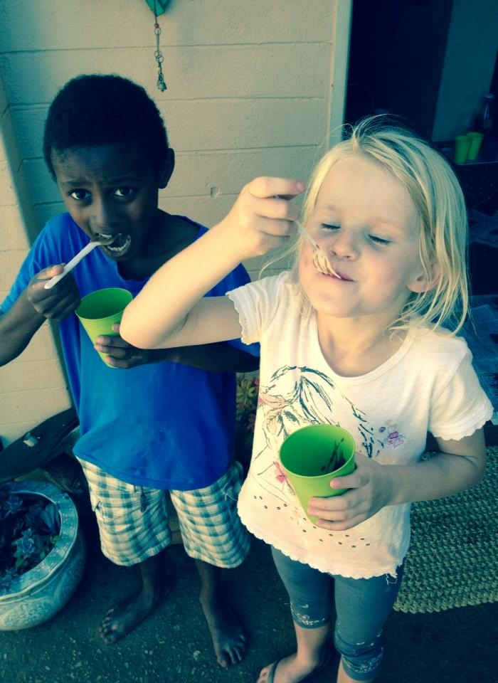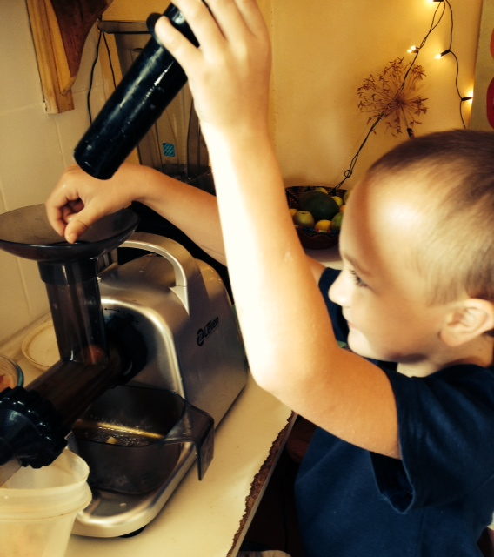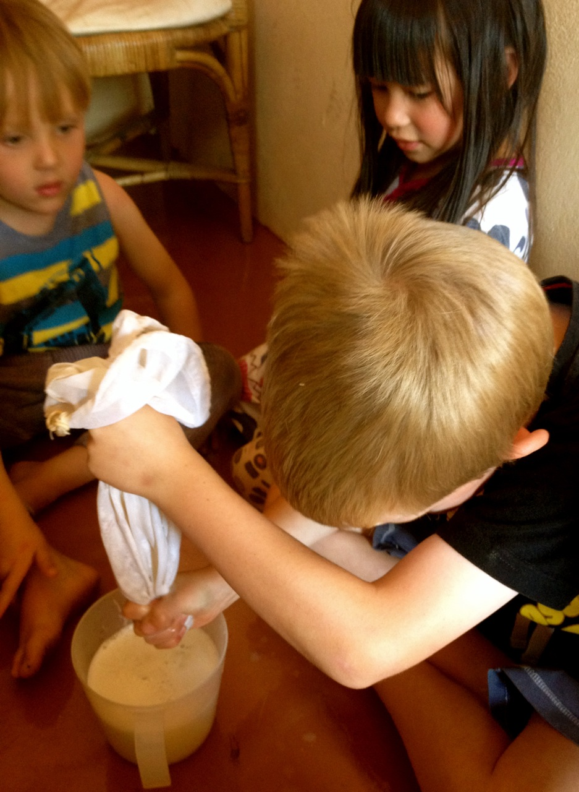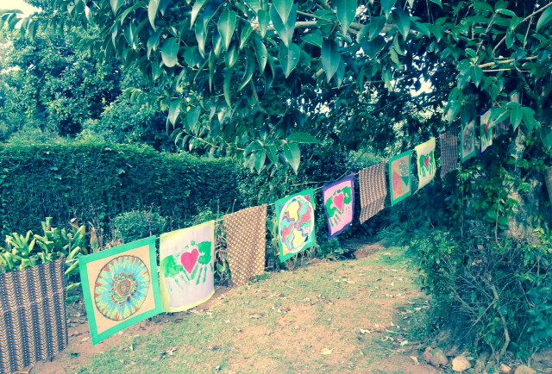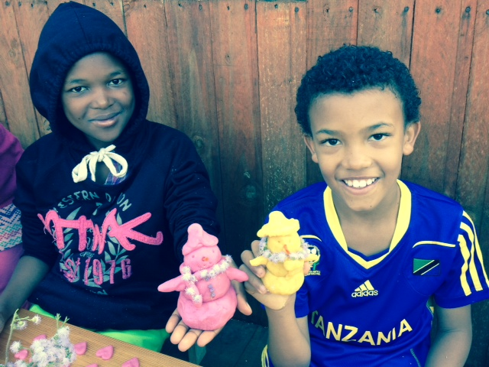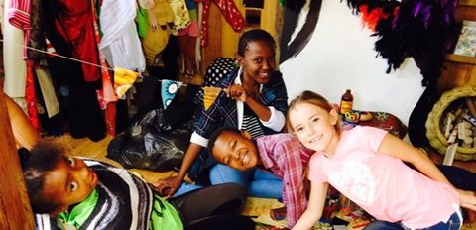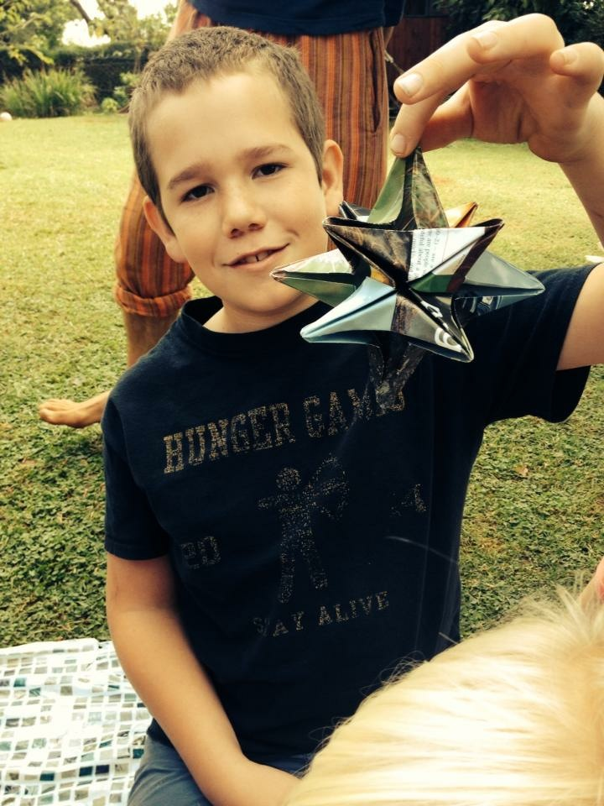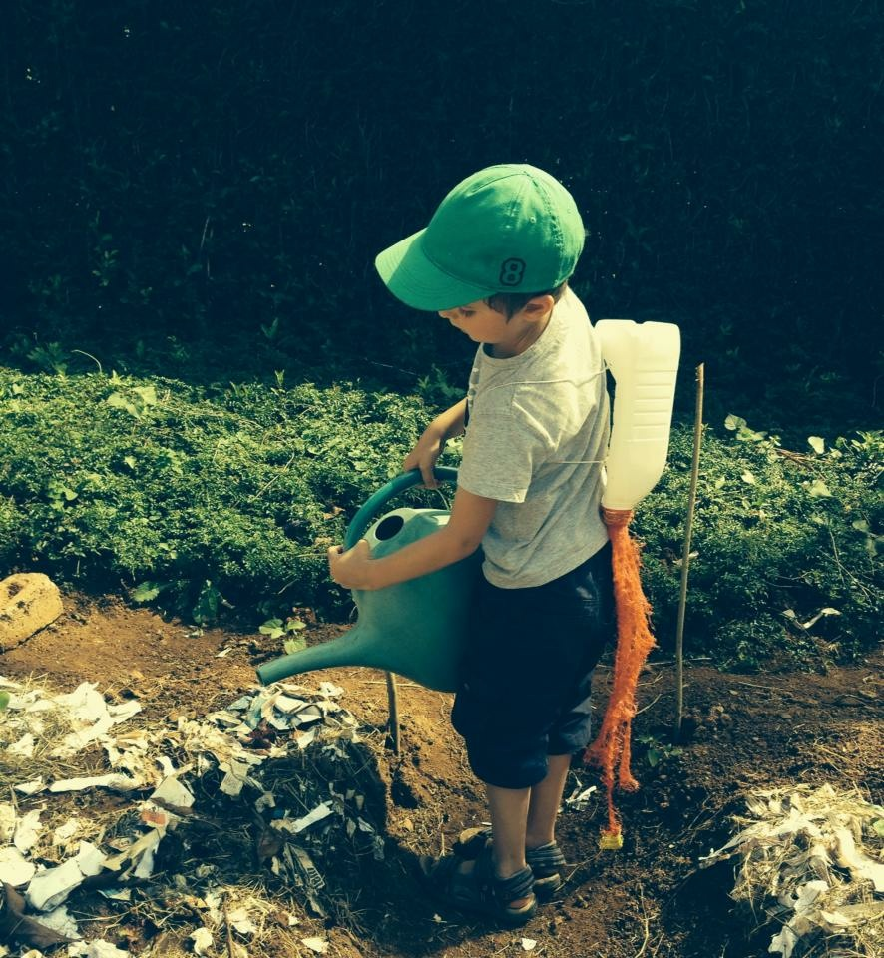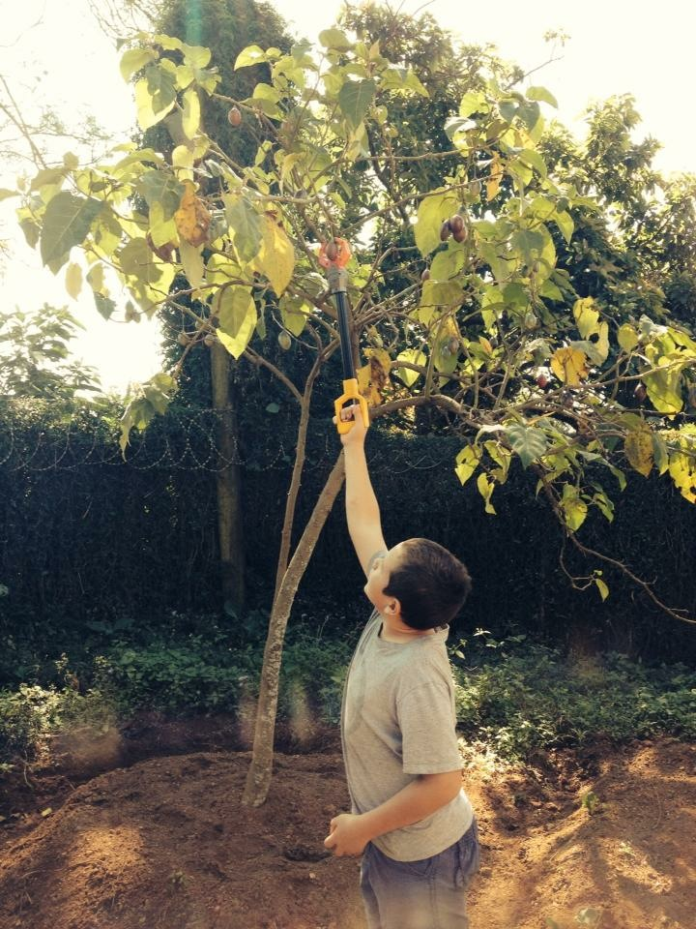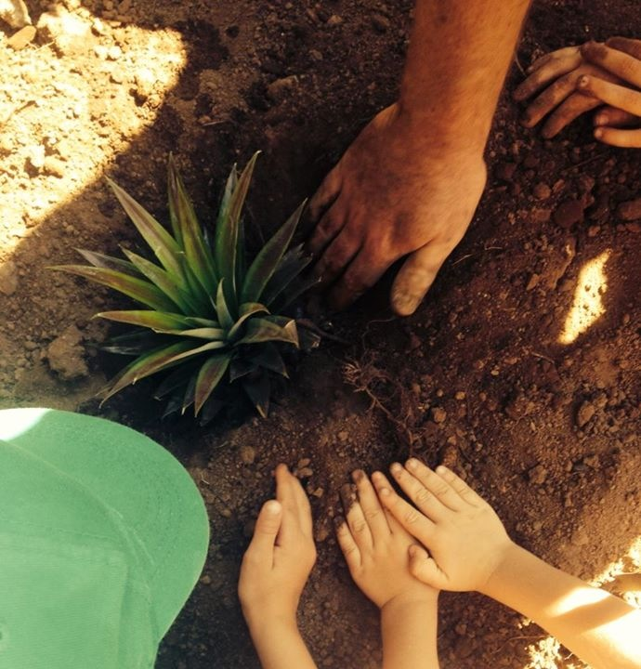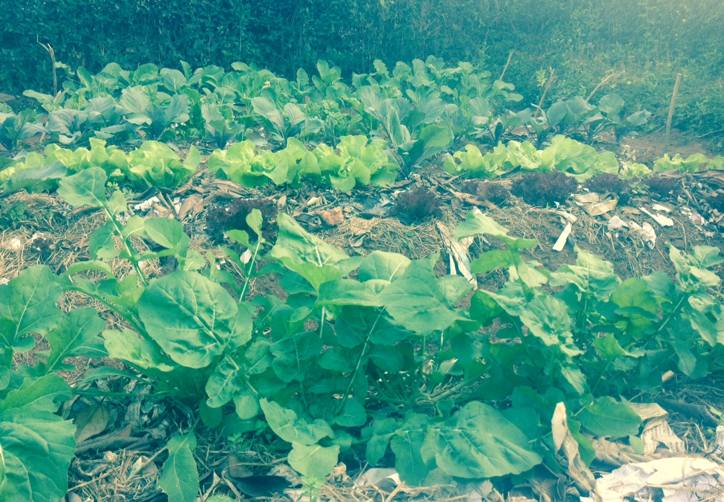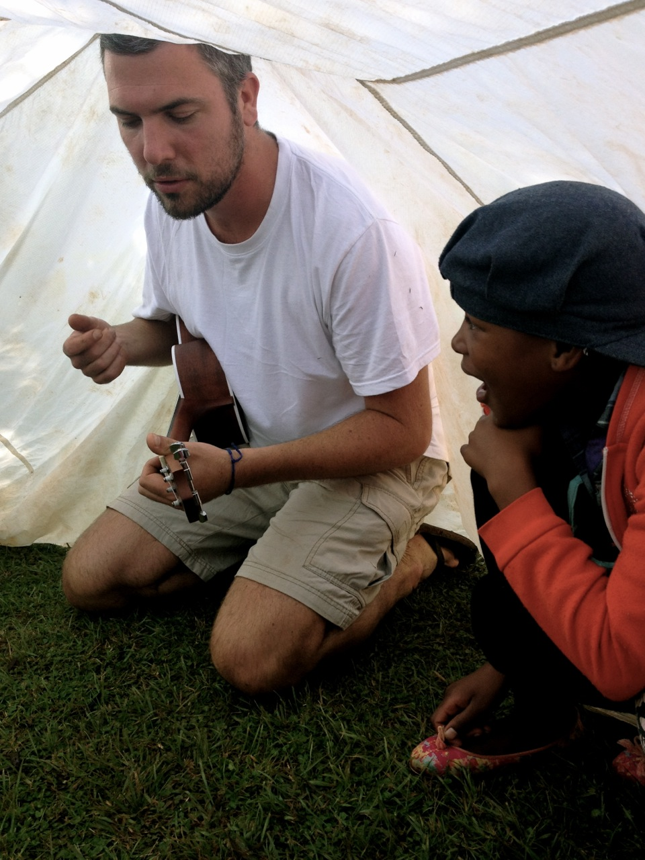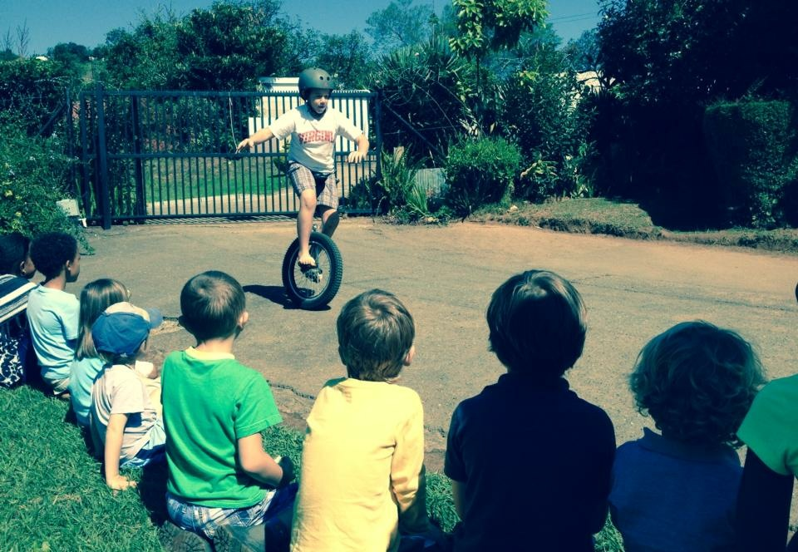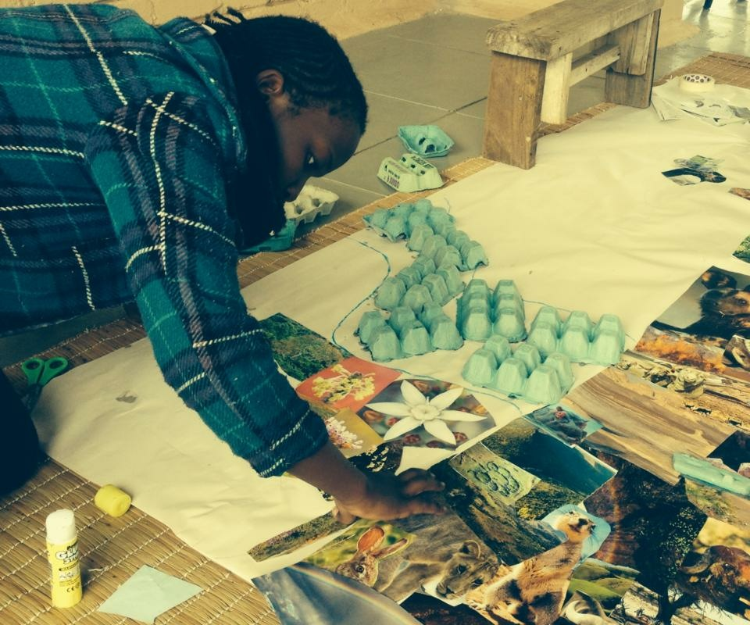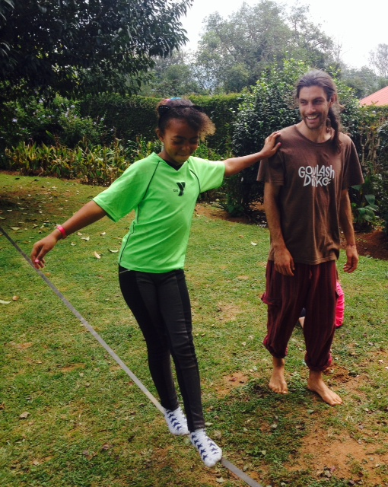

At Jelly Belly, we like to show respect for our Mothers; Mother Nature and our natural mothers too. Some of the tribe designed and made beautiful earrings as Mother’s Day presents!

Creative Beans

Jelly Belly Eco Camp

#### Happy Mother’s Day

Our wonderful Jelly Belly camp had different areas for the tribe’s different interests and rhythms. This included;

* The Jelly Belly room with dress up as well as chilled space for reading and arts and crafts
* The den for snack time and top-secret missions
* The obstacle course for mental and physical challenges such as The Old Rickety Death Bridge
* The fruit forest and crystal labyrinth for focus and centering
* Vegetable garden for connecting with the earth

### Jelly Belly

AUTUMN 2015

For two weeks the Jelly Belly tribe got barefoot and dirty, laughed, played, created and dressed up. Activities ranged from making rawlicious and delicious treats, to permaculture, storytelling, circus skills, recycled arts and crafts and dress up. We had blue skies and sunny days in every way!

# What a magical fun time with the Jelly Belly tribe!

As we head into winter, we need to arm ourselves with Vitamin C to fight off winter bugs. Seeing as oranges, pomelos and pineapples were in abundance the tribe made themselves a citrus booster juice in a finger and child-friendly masticating (chewing) juicer!

A misleading name because this pink milkshake didn’t have any milk, unnatural colouring or processed sugar. First the tribe made almond milk (we even dehydrated the pulp to make almond flour) and then blended it with the last guavas of the season. Frozen bananas made it oh-so-sweet!

Can you imagine chocolate mousse being 100% raw vegan and healthy? That’s what we made at Jelly Belly! And can you guess the secret ingredient? Avocadoes! We waited for the avos from the fruit forest to ripen and then blended them with raw cacao powder and honey. Delicious and nutritious!

## Citrus Booster

# Making Rawlicious, Delicious & Nutritious Treats

## Dried Fruit

Children love using the dehydrator because it is never too hot for their little hands (and it looks like a UFO). We cut up pineapples and Swazi bananas, arranged them on the trays and drizzled them with lemon juice to keep them from going brown. They dehydrated at 55 degrees Celsius for 6-7 hours until they were dried but still chewy. They disappeared like hot cakes!

## Chocolate Mousse

## Pink Milkshake

# Prayer Flags for Nepal

After the terrible earthquake hit Nepal, the Jelly Belly tribe started making prayer flags with messages of hope written on them. Prayers and messages such as ‘May you be safe’, ‘May you find the best medical treatment’ and ‘We are all connected’ came from the children’s own hearts and minds. Some children designed and coloured their own mandalas too. Following the tradition, the flags were hung in the morning and the wind picked up instantly, almost as if to take the prayers quickly to those in need.

At Jelly Belly we wholeheartedly believe in inspiring young children to reduce, reuse and recycle!

From the use of tin cans as pencil holders, to tyre chairs, to the use of recycled materials in our craft activities, children at Jelly Belly are exposed to creative ways to turn ‘junk’ into something useful, beautiful and/or playful. Let’s encourage our children to care for the environment.

Here are some examples of the craft activities we did with recycled materials.

* Bunting from tetrapaks and cardboard boxes
* Stilts from tin cans and string
* Flowers from toilet rolls
* Butterflies and origami stars from old magazines
* Spades and rocket jet packs from milk bottles and orange sacking
* Wallets from Tetrapak juice and milk cartons
* Picnic baskets from egg boxes
* Homemade play dough with beetroot, turmeric and wheatgrass natural dye

# Recycled Arts and Crafts

One of the most valuable tips for an abundant and healthy veggie garden is mulching! The mulch, made from dry grass and newspaper strips, keeps the water in the soil and keeps the seedlings warm through winter. Through an exciting mulch match, the tribe split into teams to mulch the vegetables beds. Thanks to the mulch, worm tea and little green fingers, look how big the veggies are now!

## Mulching

Every few days we gave the worm tub some water and waited patiently. After a while, the water passes through the tub and gets collected in a bucket under the plughole. This ‘worm tea’ is like liquid gold for the garden and is so strong it needed to be diluted before the tribe put it on the seedlings they planted.

After the pineapples were juiced, the tribe took it in turns to ‘screw’ the tops off the pineapples. They then peeled away the bottom leaves until tiny roots appeared. The tops were planted in tyres and mulched (see below) to help them grown through the winter. Fingers crossed we will have pineapples growing before long!

In order for the children to understand the cycle of the worm tub compost, we began by harvesting tree tomatoes and kale from the veggie garden. These were juiced and after the juice was drunk, the ‘waste’ pulp was put in the worm compost, which lives in an old bathtub in the veggie garden.

## Harvesting Fruits & Veggies for Juice

# Permaculture

## Worm Tea

## Planting pineapple tops

Our first story was Themba and the Trees, a charming story based on a real life event when a village of women in India saved a forest from being cut down by hugging the trees. Inspired by the story, the tribe created a Tree of Life wall hanging. Drawing around two children lying in different positions on the paper created the outline of the tree and river. Pictures of animals collaged together made up the tree trunk, blue scraps formed the river, egg boxes created the rippled effect, while handprints formed the leaves. Flowers, butterflies, clouds and the sun were added to show their interconnectedness.

Our second story was All Things Are Connected, in which a cruel chief learns (the hard way) how all living things are connected. This powerful lesson was woven through every activity we did!

Our third story was told and performed through song, with Captain Ted on the ukulele!

# Circus Arts

The tribe really worked on their circus skills this Jelly Belly. Many children got to show off their new skills during the circus parade at the end-of-camp show. Circus skills practiced include;

* Slack line
* Juggling
* Stilt walking
* Silk dancing
* Clown
* Unicycle
* Hula hoop
* Diablo

# Storytelling

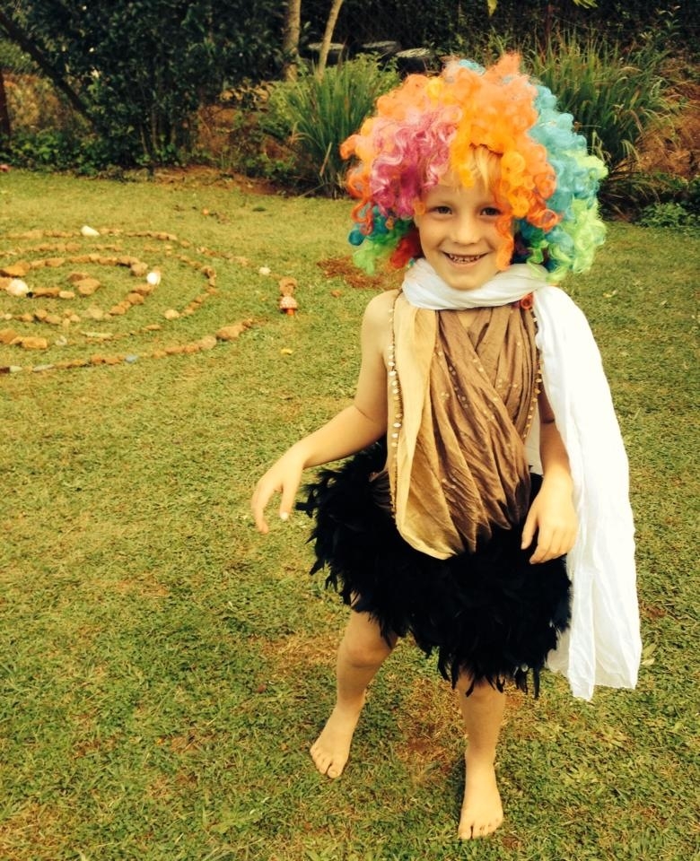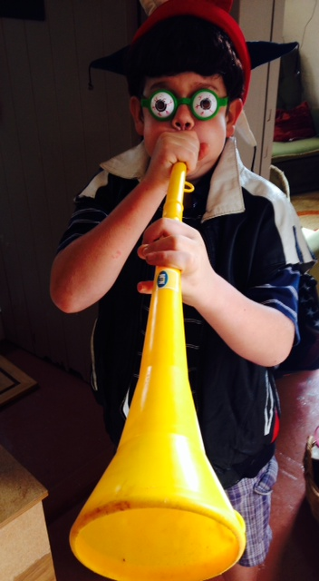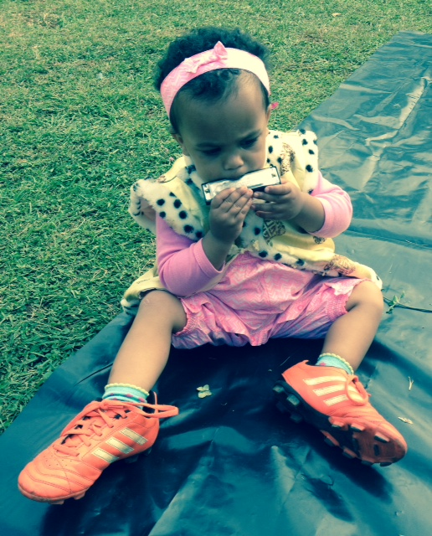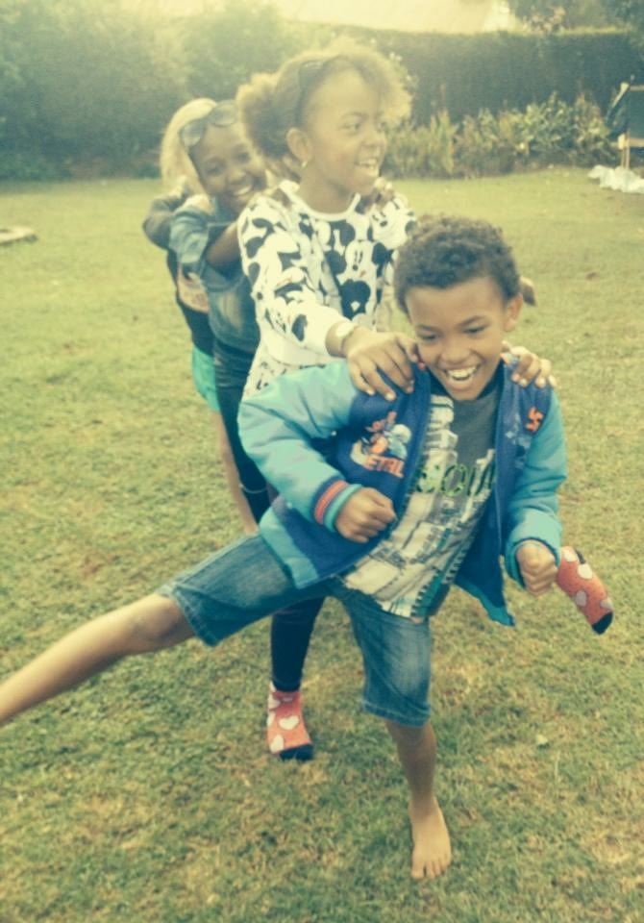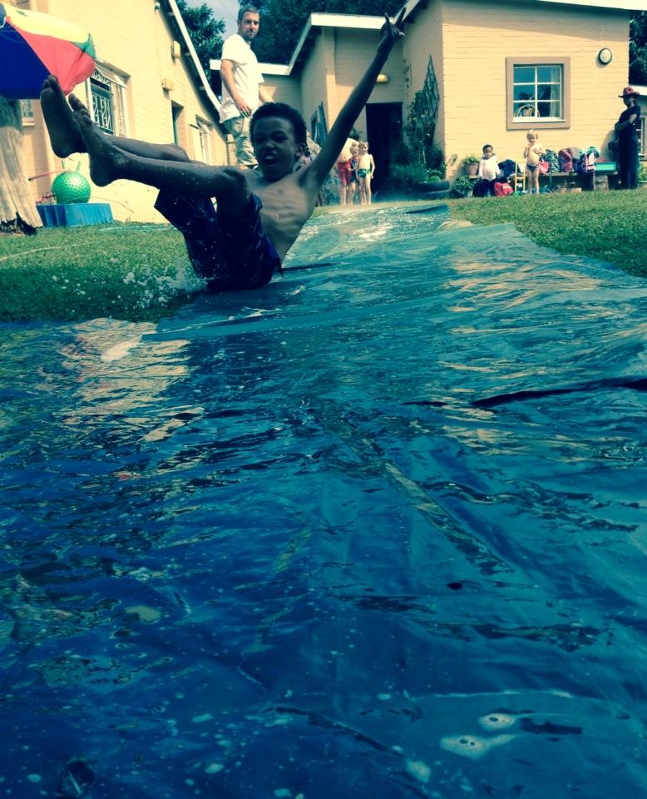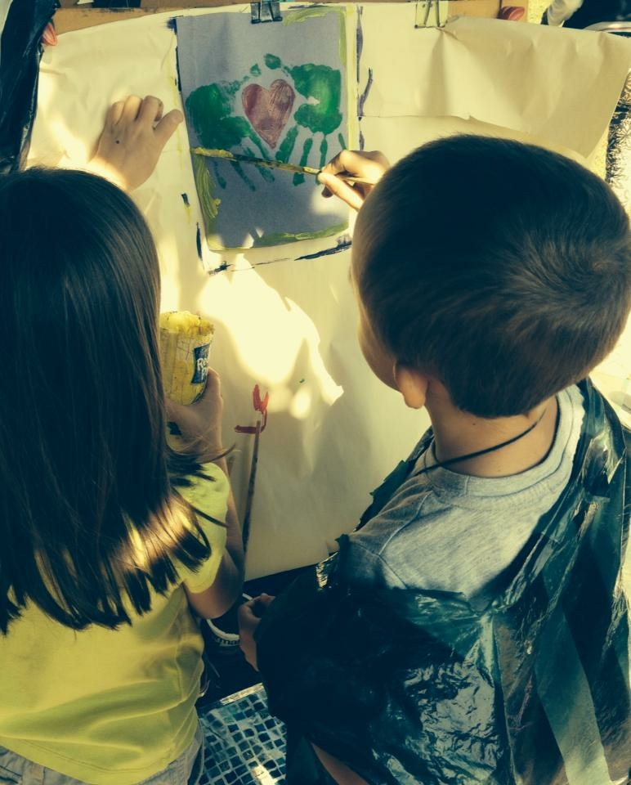

★ Captain Banana ★ Captain Monkey Pants ★ Captain Ted ★ Captain Purple ★

Like and follow Creative Beans on Facebook or check out the website

<http://www.creativebeans.weebly.com>

It takes a whole village to raise a child

African proverb

SIYABONGA

AUTUMN 2015

JELLY BELLY